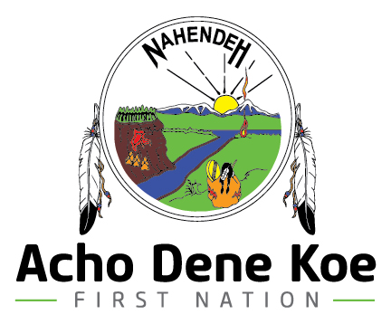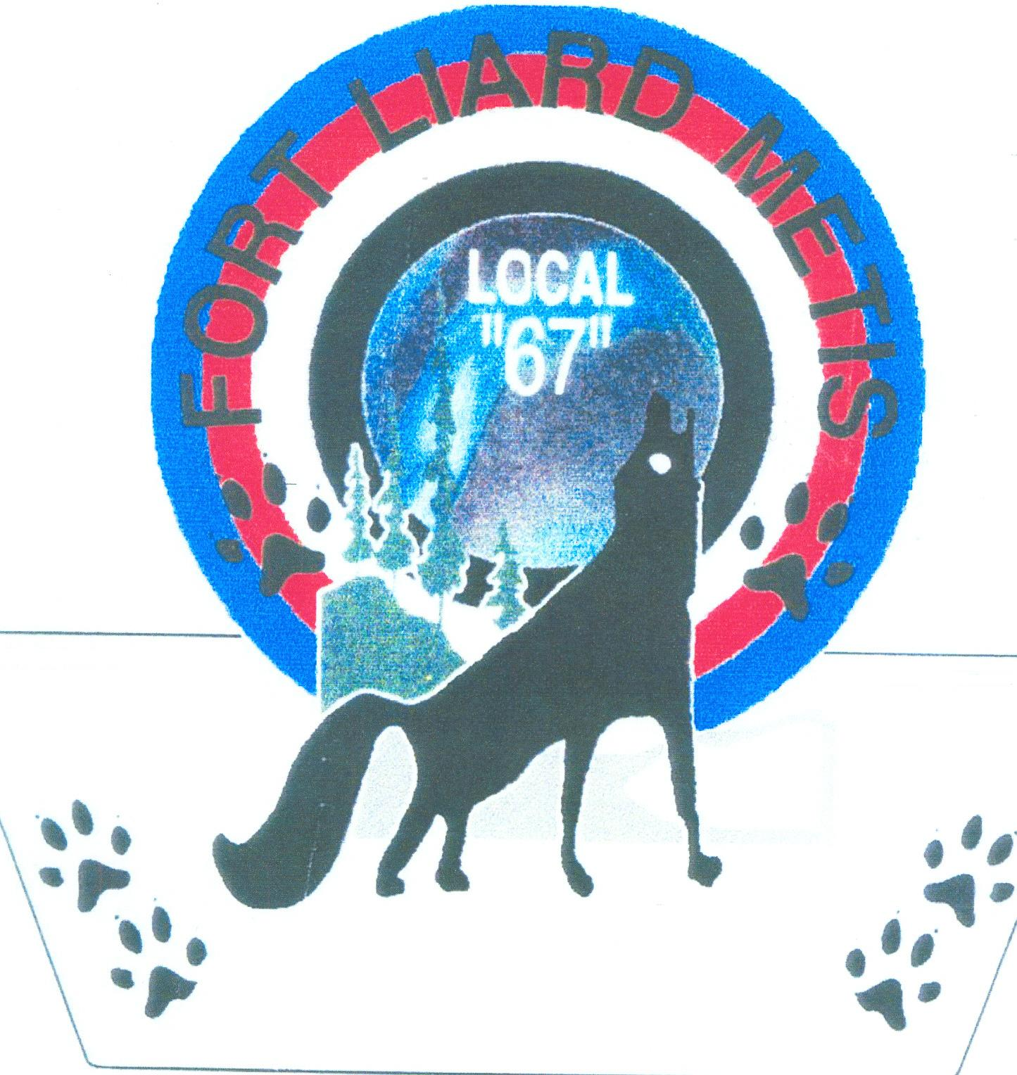 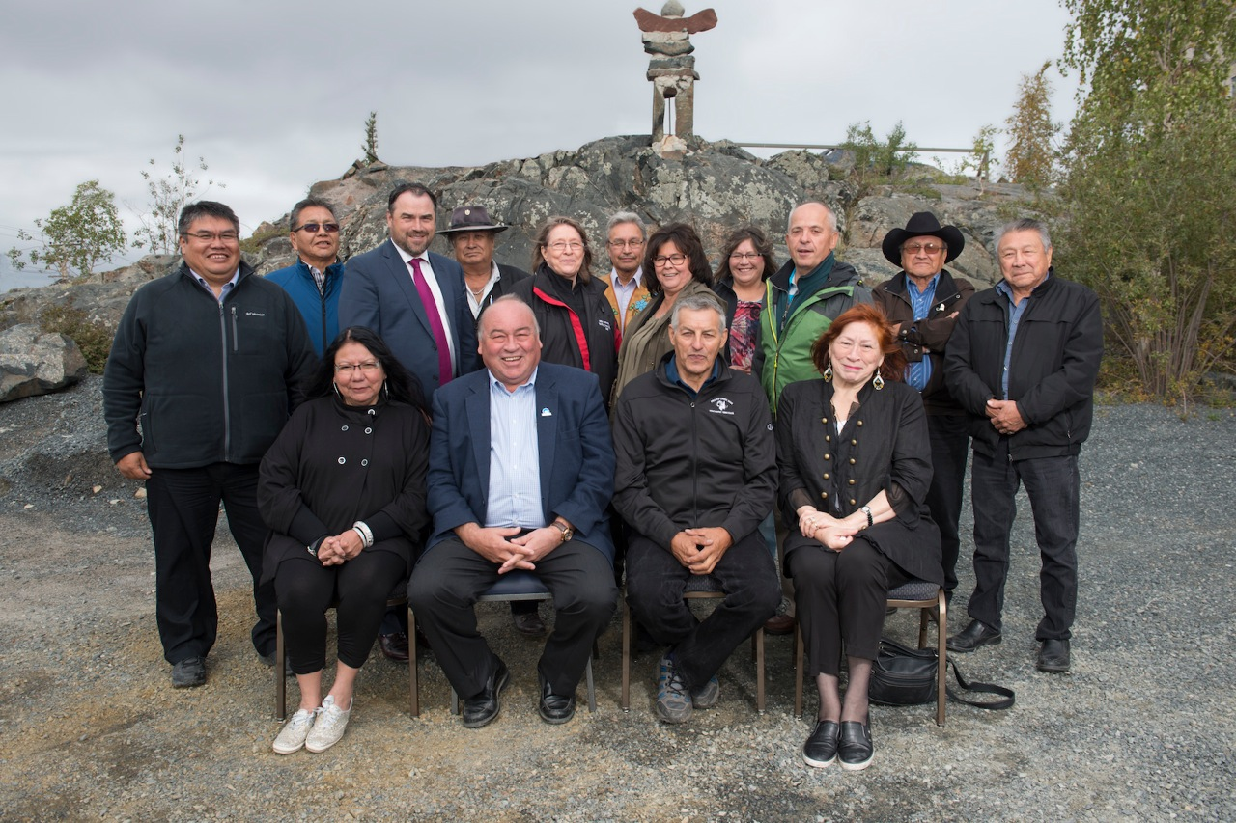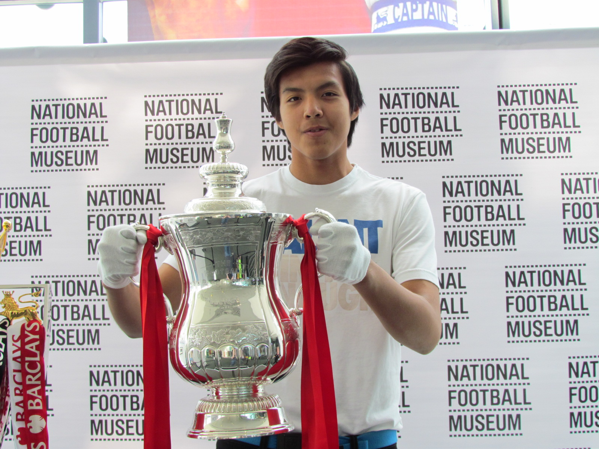

If you have any content that you would like included in next month’s edition, please contact Ivy-Lynn Marcellais at the Band Office by **October 16th**

T: (867) 770-4571

F: (867) 770-4573

E: ivymarcellais@adkfistnation.ca

### September 2015

The ADK wrapped up its summer negotiation season with a visit from Premier Bob McLeod August 27, 2015. During the summer months the ADK team resolved some of the outstanding Final Agreement issues in the NWT, and also continued to pursue a mandate to enter into negotiations with the Government of Yukon.

As we all know there will be both federal and territorial elections held this fall. As a result, the ADK has been informed that as of August 6, 2015 treaty negotiations with Canada and the GNWT have been put on hold until after the federal election. More than likely a similar message will be sent by the GNWT when the territorial election campaign begins.

Although main-table negotiations have been put on hold, the ADK is still working on Implementation and Lands Selection initiatives. Accordingly, the lands selection technical group led by Rob Diaz formally submitted its selection of 6474 square kilometers of Settlement Lands in the NWT. Chief and Council reviewed the proposed Settlement Lands during the week of August 24 when Rob was in Fort Liard. If any community members are interested in seeing the map detailing the proposed ADK Settlement Lands they are encouraged to come to the Band Office and talk to Kayly Deneron.

The ADK anticipates main-table treaty negotiations to start again sometime in December 2015 or early January 2016. In the interim, the ADK will continue to work with John McKee as he overhauls the Bands administrative systems, as well as take part in Devolution meetings planned for November. When negotiations do restart the ADK team will be pressing to complete Final Agreement negotiations in the NWT as soon as possible in order to developed a closing and implementation plan for the new treaty.

# ***Negotiations Update***

THE fort times

Acho Dene Koe First Nation leadership, Harry Deneron, Steve Kotchea, and Fort Liard Métis President Ernie McLeod met September 3, 2015 in Yellowknife at the Second Intergovernmental Council meeting. The Intergovernmental Council is a key feature of the Devolution Agreement. The Council allows Aboriginal governments to cooperate and collaborate with the GNWT on matters related to lands and resources management.

Joining the ADK team were leaders from the GNWT, Inuvialuit Regional Corporation, Northwest Territory Métis Nation, Sahtu Secretariat Incorporated, Gwich’in Tribal Council, Tłı̨chǫ Government, Salt River First Nation, Denínu Kų́ę́ First Nation and the Kátł’odeeche First Nation. During the meeting the parties discussed a range of lands, water, and resources issues including resource revenue sharing, capacity building, the state of the resource economy and an update on conservation work in the NWT. The group also charted a path forward for the coming year’s work that will focus on many of the same issues as well as some new initiatives.

In private, at the leaders morning breakfast and during scheduled breaks, leaders from many of the other Aboriginal governments in attendance spoke with ADK leadership to express their support for the ongoing ADK treaty negotiations. The words shared between the leaders of the ADK and those leaders who represent Aboriginal governments with settled land-claims were encouraging.

Moving forward, the ADK will continue to send representatives to Intergovernmental Council Secretariat meetings throughout the fall. The ADK Chief and Council has selected Councilmen Steve Kotchea to represent the Band at these meetings in order to ensure the ADK remains an active participant and lands and resources management initiatives throughout the NWT.

# **ADK’S CONTINUED INVOLVEMENT**

# **IN DEVOLUTION**

Before I start this off I would like to send a big thank you to TransCanada and ADK. Without their generous support I would have not attended one of the most exciting and daring trips few would dare to do. I would also like to send a huge thanks to the Northwest Company and the Northern store for sponsoring me on my trip as well. Without such caring co-workers and staff, I would not have had the time or funds to pull this off. I would also like to give another thanks to the community of Fort Liard, and to every single person that contributed to my trip! Thank you all for being so supportive! Lastly, I would like to thank Mrs. Roslyn Firth for helping me organize my trip with Mr. Ollie Williams, whom most of you know accompanied me on my adventure, Anna from the Northern store, for all your help and effort to make this happen and to my parents, whose permission let me explore a whole new world. Thank you everyone!!!

To start off my journey I, James Anthony Duntra, left my hometown of Fort Liard around 9 am on the morning of July 28th. "What a big journey to undertake" I thought as we made our way to Fort Nelson, BC. My mother and auntie were driving me down to Fort Nelson for my flight out to Edmonton, Precious was also with me that morning, she wanted to spend my last hours in town before I leave for my 2 week journey. My flight left at 2 pm that afternoon and waving me farewell was my mother and Precious. I bordered the plane and was off to Edmonton where Mr. Gowans (my former teacher) was awaiting me. Being on that airplane was the first time that I ever felt so alone. That evening I arrived in Edmonton where my old teacher greeted me. We got up early the next morning and headed for the Edmonton International Airport, where we went to pick up Ollie Williams, a former Fort Liard soccer coach and beaver volunteer. 5 hours later and it was time to board our international flight that would be taking us to Toronto, then Manchester, England. I was never on and airplane for more than 4 hours and my first time being on an airplane for an overnight flight was hard, I was so excited to see England! I remember very clearly trying to look out the window to get a glance of one of the football capitals of the world.

As my first time out of my native homeland Canada, I was excited to see different people and places. My mind was racing with excitement! We landed around 10:30-ish in the morning, which was about 3:30 am in Fort Liard. I was wide wake and excited to be in a foreign place for the first time. After getting passed Border Control and waiting for our rental car, Ollie and I were off to Manchester! I remember taking in everything; the scenery, the way they drove on the opposite side of the road, the buildings and the people! There were so much of them! We arrived in Manchester, and at the hotel where we would be staying. I found that the jet lag was setting in. I felt very tired and it was 6 in the afternoon, so Ollie and I found some things to keep us busy until it was time to go to sleep.

It was the morning of the 31th of July 2015 and I was wide-awake, I found it hard to sleep when I was supposed to and not to sleep when I wasn't supposed to. Anyways Ollie had arranged for us to visit the National Football (Soccer) Museum!!! The museum was amazing. There were lots of historic football memories in that place. After visiting the museum, Ollie also arranged for us to tour the Etihad Stadium. One of the best Stadiums I’ve ever seen. It was a long day for me, seeing two of Manchester's iconic places was a lot to take in for a young lad who lives in a Village of 600 people. The next day consisted of sightseeing and hiking in Britain's most scenic district, which is called the Peak District. Ollie planned our hike, preparing me for the Soccer camp for the next day.

August 2nd, the day I left for the soccer camp. That day I remember being very nervous since I was leaving the only person I knew and the campgrounds were huge. There were already hundreds of people there, and I was one of them. Ollie escorted me to my room and I got settled in. I said my goodbyes and then he left, only to be seen 5 days later at Old Trafford. Later that day I had my first training session. Boy, was I nervous!! Everyone in my group was awesome, and there was lots of diversity in terms of nationalities. I had a fun first session, met lots of players and got to experience the true way of playing football, on an outdoor pitch!

Waking up that next morning was torture, having such a physically demanding session left me tired and overcoming jet lag was still a challenge.

Basically, everyday of those five days went like this:

* Breakfast at 9:15
* Training session at 10:15 till 12:30
* Lunch at 1:15
* A classroom session, plus a skill challenge from 1:30 up until 4:15
* Dinner at 5:15 then a tournament at 6 until 9 o'clock VS one of the 15U, 16U or 17U age division groups

I've met people who enjoy playing soccer as much as I do and who are determined to play their best. Everyone gave a hundred and ten percent!! The attendees were nice and friendly, especially to a person who comes from such a small and isolated community. I had to explain and answer several questions from my new, curious friends. Many thought that I was from Asia and they wondered about my lifestyle since my community is small. I had an exciting time; the coaches and drills were very different than what I was expecting. Because of the experience, I learned new tactics and ways to play the game.

The last day of my camp we took a tour of the Manchester United football stadium, in Old Trafford. Home of the Red Devils! After our closing ceremonies and saying goodbye to all my new and interesting friends, Ollie and myself went back to the hotel to recover from my tiring week. By this time, my trip was half done. I met lots of people and I was enjoying my time in England. England was a fantastic trip!! Gosh, I loved it so much.

August 8th! Was the day I’ve been dreaming about since I watched my first game and started playing soccer eight years ago. I, James Duntra, attended a Premier League soccer match! There I was, standing in front of one of the most iconic stadiums in the world, the Theatre Of Dreams, about to watch Manchester United VS Tottenham Hotspurs. Man, I will never forget that day! It was unbelievable to watch some of my favourite soccer players; play in one of the biggest leagues in the world. I was one out of 85,000 people. The atmosphere was crazy! I will never forget the chants, the singing and all that screaming after they scored a goal. England was one of the best things that ever happened to me and my overall experience at the camp was a memorable one. Thank you to everyone who helped me reach my goal!

***James is currently still in school and is looking at options for post-secondary when he graduates. James has a strong interest towards kinesiology. In the mean time, he is putting the skills that he’s developed playing soccer through out the years and while in Manchester, by helping assist with the local soccer team. The Chief, Council and Community are proud of James’ hard work, dedication and growing passion towards the sport.***

***Keep up the good work James!***

***The following was written by ADK Youth and sport enthusiast, James Duntra. Last month, James attended a weeklong soccer camp in Manchester, England - home to one of the world’s most famous soccer teams, and one of the world’s largest stadiums. James has summarized his experience for community members and hope that you all enjoy the read.***

## MY TRIP TO ENGLAND

*Touring the National Football Museum and James couldn’t pass up the opportunity to hold a replica of the trophy that each team receives after winning the premier league.*

***James is currently still in school and is looking at options for post-secondary when he graduates. James has a strong interest towards kinesiology. In the mean time, he is putting the skills that he’s developed playing soccer through out the years and while in Manchester, by helping assist with the local soccer team. The Chief, Council and Community are proud of James’ hard work, dedication and growing passion towards the sport.***

***Keep up the good work James!***



**$200.00 REWARD**

Recently a number of windows were broken at the Acho Camps & Catering Base Camp.

A reward of $200.00 is being offered by ADK Holdings Ltd. for information **leading to the successful conviction** of those responsible.

Should you have any information, contact the RCMP at 770-1111

### “The Fort Times”

### is also featured on ADK’s website.

### [*www.adkfirstnation.ca/community*](http://www.adkfirstnation.ca/community)

BAND COUNCILLORS

Joe Bertrand

Steve Kotchea

Irene McLeod

Cathy Kotchea

Dennis Nelson

Sonia Timbre

The Band Office will be closed for Thanksgiving on Monday, October 12

Office will reopen on

Tuesday, October 13 at 9 am.

***&***

***Have a safe long weekend!***

**ADK PHONE DIRECTORY**

**184 1910 Poplar Road - Fort Liard, NT X0G 0A0**

**Telephone: 867.770.4571 Fax: 867.770.4573**

**Chief and Council – Ext 265**

Harry Deneron, Chief Negotiator

Email: [achodenekoe.hdeneron@northwestel.net](mailto:achodenekoe.hdeneron@northwestel.net)

**Management – Ext 260**

Band Manager

**Administration – Ext 253**

Adilene Marcellais, Executive Assistant

Email: [achodenekoe.marcellais@northwestel.net](mailto:achodenekoe.marcellais@northwestel.net)

**Land and Resource Department – Ext 232**

Kayly Deneron, Lands Coordinator

Email: [achodenekoe.kdeneron@northwestel.net](mailto:achodenekoe.kdeneron@northwestel.net)

Alex Fanni, Lands Coordinator

Email: [achodenekoe.fanni@northwestel.net](mailto:achodenekoe.fanni@northwestel.net)

**Communication and Development – Ext 224**

Ivy-Lynn Marcellais, Community Liaison Officer

Email: [ivymarcellais@adkfirstnation.ca](mailto:ivymarcellais@adkfirstnation.ca)

**Liard Metis Local 67 – Ext 227**

Ernie Mcleod, Metis President

Email: [achodenekoe.mcleod@northwestel.net](mailto:achodenekoe.mcleod@northwestel.net)

**ANNOUNCEMENTS**

**This information is distributed without prejudice, and intended solely for information purposes for members of the Fort Liard community and those with associated interests. It may not be reproduced or disseminated further without the expressed permission of Acho Dene Koe First Nation.**